Evaluation Warning: The document was created with Spire.Doc for JAVA.

tat' ca?

thu? tuong'

han. che'

Evaluation Warning : The document was created with Spire.PDF for java.

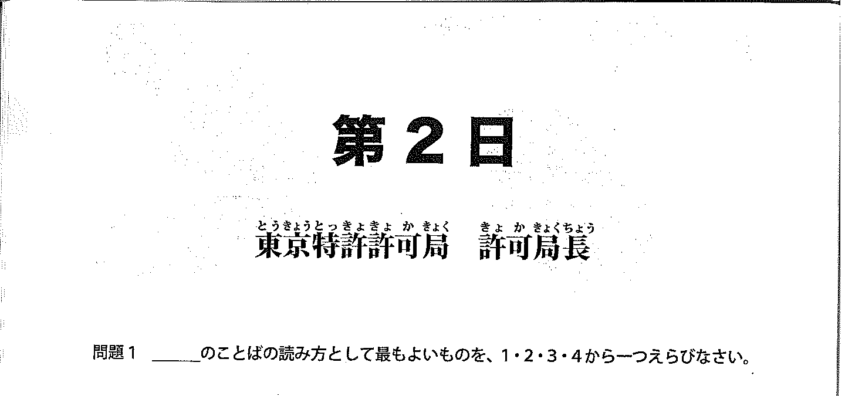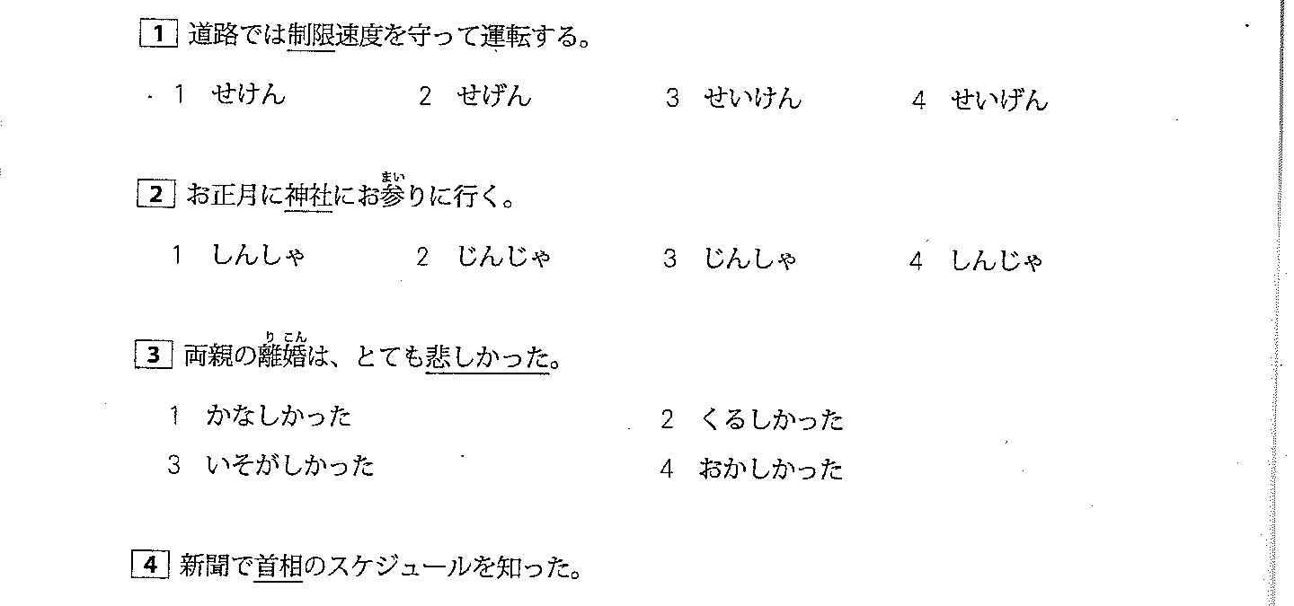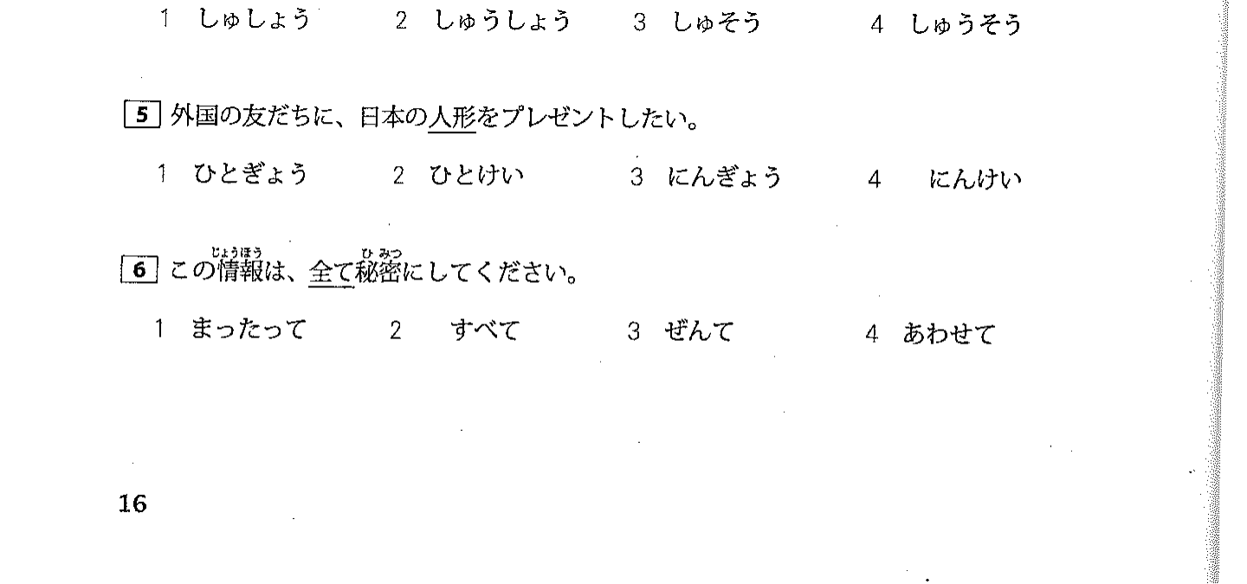

minh` (ban? than)

thanh thieu' nien

tien` hoc. phi'

Evaluation Warning : The document was created with Spire.PDF for java.

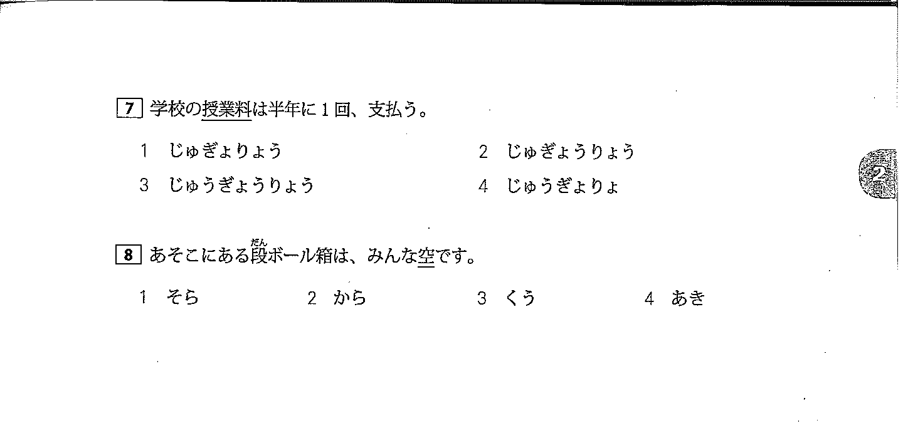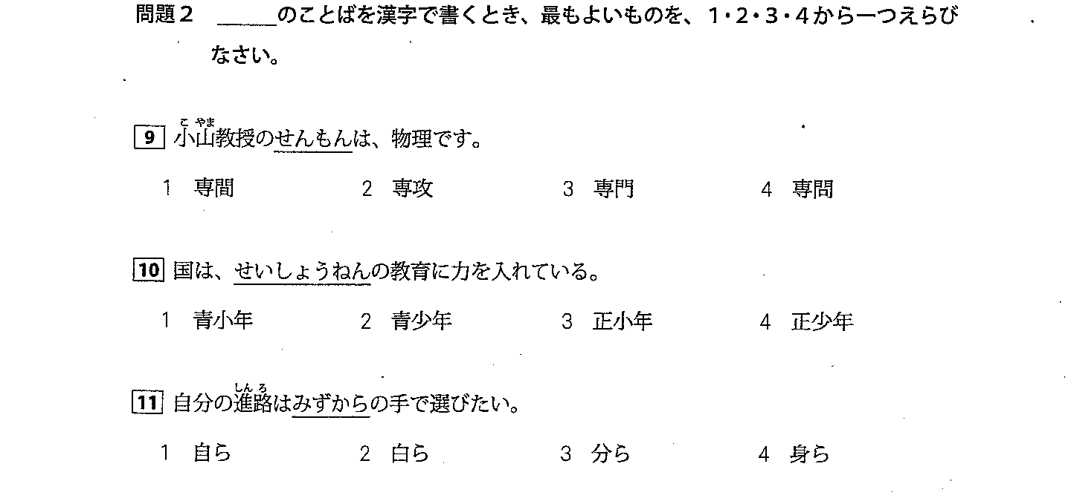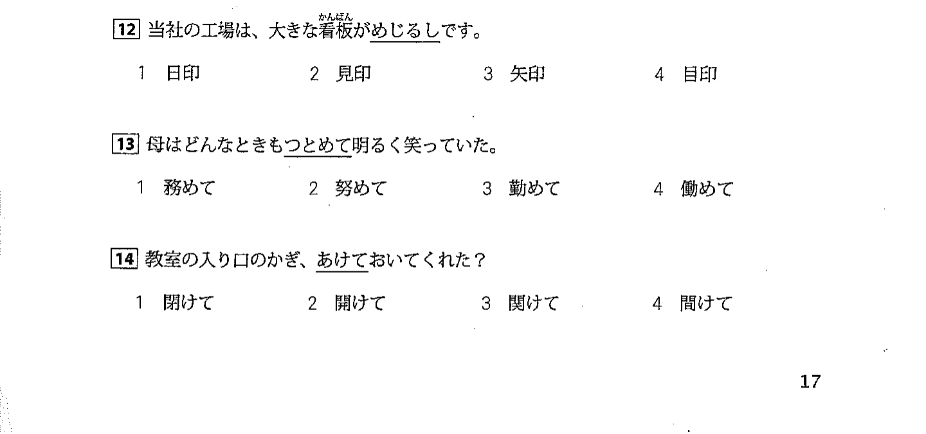

moi~ ca' nhan

saishinkan: tap. moi' nhat'

vui ve?, tuoi vui

dekirukata

shinpai

goc'

can? tro?

coach

Evaluation Warning : The document was created with Spire.PDF for java.

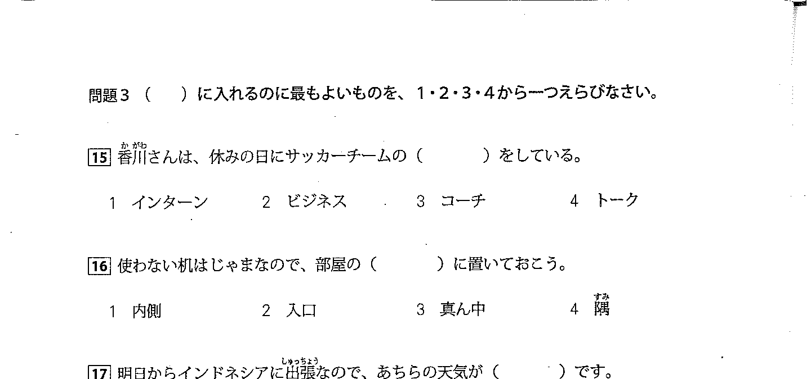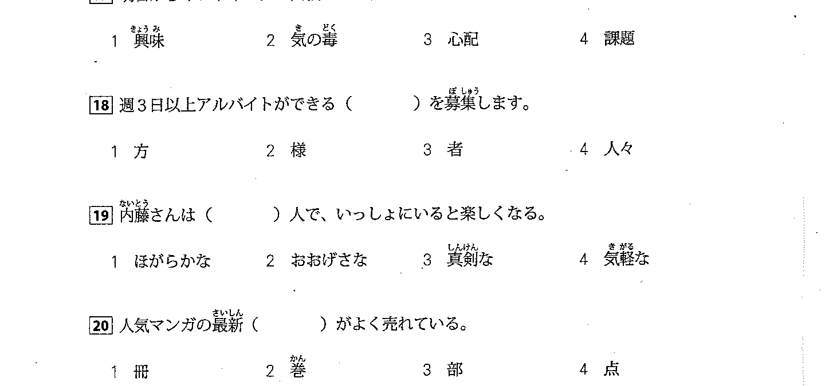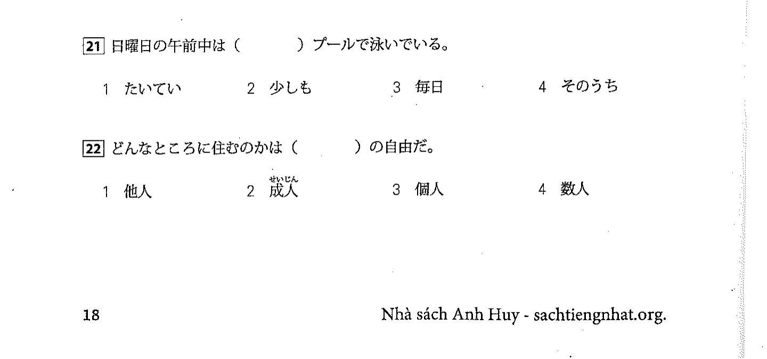

an' tuong.

ki' uc', tri' nho'

chan'

chan'

duoi? theo; duoi? kip.

di vuot. qua

tro. tu` "ni" + ~

print

password

Evaluation Warning : The document was created with Spire.PDF for java.

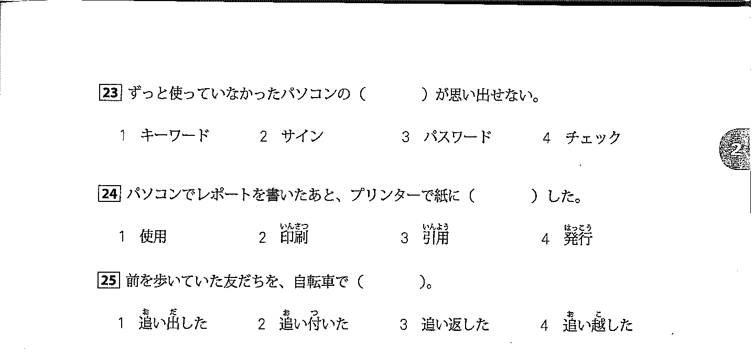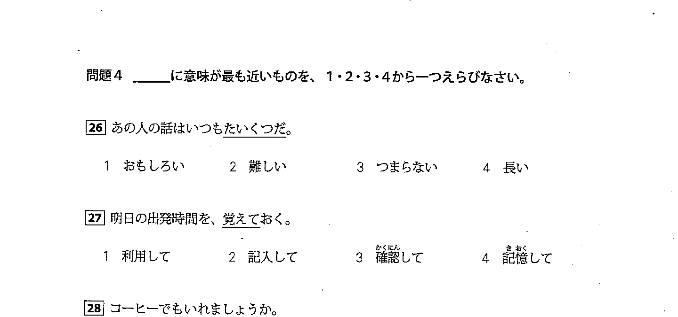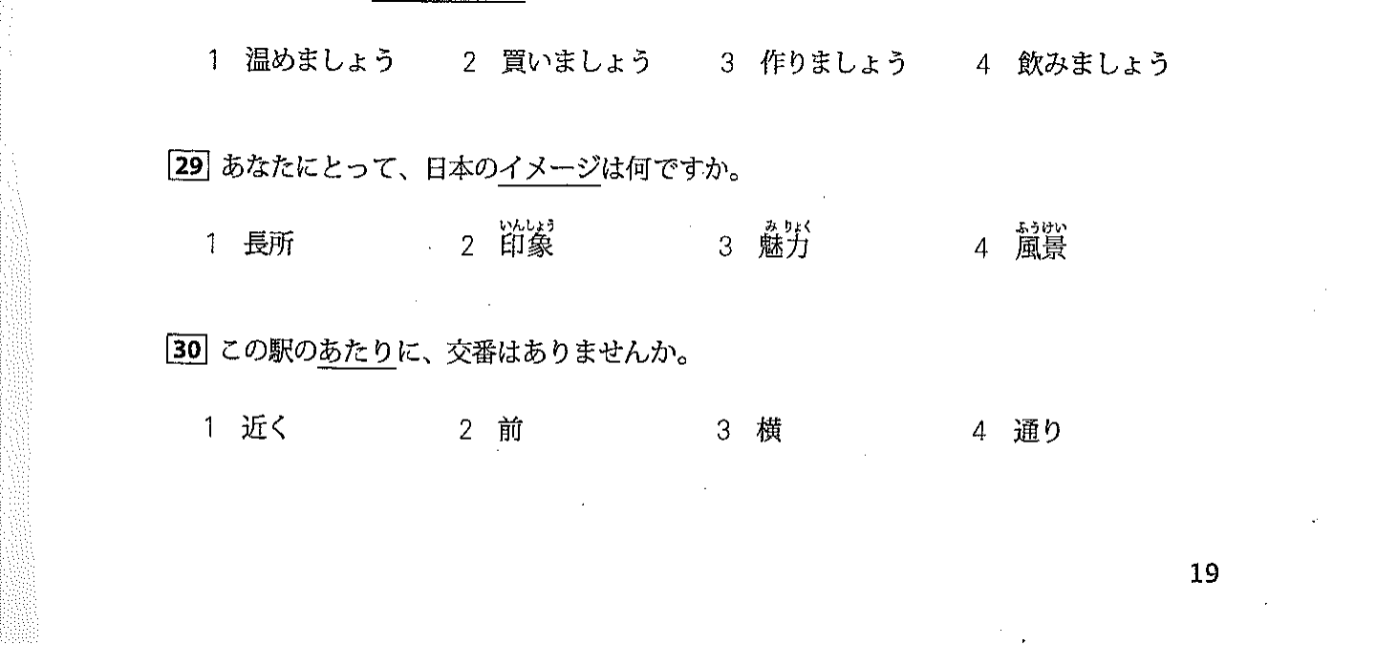

tot' hon

kha' la` ~

quan tam

Evaluation Warning : The document was created with Spire.PDF for java.

